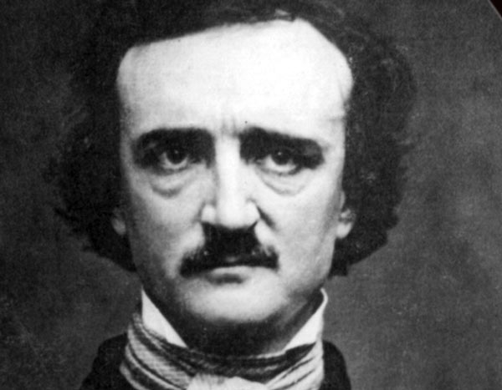 (1809-1849) 

Edgar Allan Poe was born in Boston, the son of itinerant actors. His father left his wife eighteen months later and his mother died soon afterwards, so that the child was brought up by the family of John Allan, a Scottish tobacco exporter. Poe attended the university of Virginia, left because of gambling debts, ran away to Boston and started writing poetry. Having unsuccessfully tried the army and West Point, he became a hack writer in Baltimore and, later, Philadelphia, and started editing literary magazines, an occupation at which he excelled thanks to the quality of his editorial writing and reviews. His personal instability, however, made it difficult for him to stay long in one job. In 1835, he married his thirteen-year-old cousin Virginia Clemm. Though Poe had by then gained recognition for his poem and stories, his last years were marred by his wife’s illness (she died of tuberculosis at the age of twenty-five), by his poverty and by his own eccentricities and drinking bouts. Pictured as a depraved opium addict by his detractors and as a misunderstood genius by his admirers and translators (Baudelaire and Mallarmé regarded him as the precursor of the French Symbolists), Edgar Allan Poe was long undervalued in America. Poe wrote three types of tales. The grotesque tales are early, sensational stories of the bizarre and the macabre which show the influence of German romanticism and the gothic trend. The arabesque tales focus on the psychology of terror, exploring dreams and hallucinations, combining the natural and the supernatural and creating further mystery by the use of unreliable narrators. The tales of ratiocination are detective stories (Poe invented the conventions of the genre).



Main works :

The Fall of Murders The Black Cat/ The Raven Annabel Lee
The House in the Rue The Tell-Tale and other (Poem)
Of Usher Morgue Heart Poems

1839 1841 1843 1845 1849

Edgar Allan Poe

Where was he born ?
Edgar Allan Poe was born in 1809 and died in 1849.
What happened to his parents ?
His father left his wife eighteen months later and his mother died soon afterwards.
Where was his University ?
Poe attended the university of Virginia.
What did he do after university ?
He started writing poetry.
Who did he marry ? What happened to her ?
In 1835, he married his thirteen-year-old cousin Virginia Clemm. Sadly, she died of tuberculosis when she was only twenty-five.
Poe’s life on a map. Choose the right path :

- Philadelphia – Baltimore- Florida
- Arizona- Virginia- Philadelphia.
- Boston- Virginia-Baltimore- Philadelphia

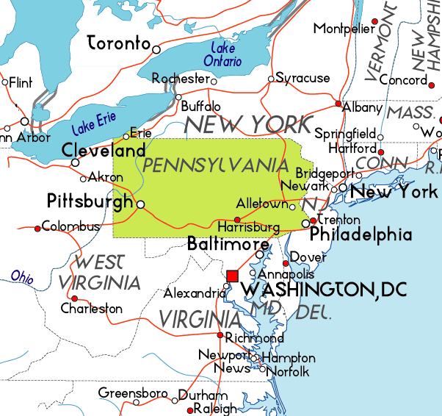
Poe’s work ? Choose the right path :

- Army-University- Hack writer- Edit literary Magazines.
- Edit literary magazines- University- Hack writer- Army.
- University-Army-Hack Writer-Edit literary Magazines.

Which kind of stories?
- Grotesque tales (bizarre-macabre)
- Arabesque tales (psychology of terror-dreams-hallucinations- natural-supernatural-mystery- unreliable narrator)
- Detective stories
- Comic books

