
Source : https://www.nbcnews.com/news/us-news/football-player-killed-police-during-break-in-had-drugs-system-n420601

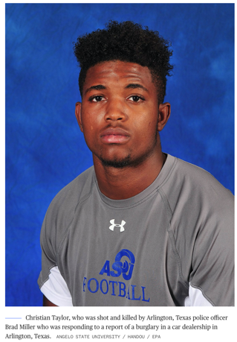
Sept. 3, 2015, 12:35 AM CEST / Updated Sept. 3, 2015, 12:38 AM CEST
By Phil Helsel
The college football player fatally shot by a rookie police officer during a break-in at a car dealership in Texas last month had traces of a psychedelic drug in his system, an initial autopsy report has found.
Christian Taylor, 19, was unarmed when he was shot and killed by Arlington police officer Brad Miller at a car dealership in the early morning hours of Aug. 7.
An autopsy report released Wednesday said tests determined the presence of a "synthetic psychedelic drug" that can cause hallucinations. Tests also found the presence of THC, the psychoactive element of marijuana, in an amount consistent with recent use.
Taylor, a sophomore at Angelo State University in San Angelo, was acting erratically and stomped through the windshield of a parked Ford Mustang before crashing his Jeep Grand Cherokee into the dealership, surveillance video shows. He allegedly told an officer who responded that he was there to steal a car, Arlington Police Chief Will Johnson has said.
Miller, a 49-year-old recruit officer finishing up his year of supervised training, was found to have used poor judgment in entering the dealership alone and without telling other officers. He was fired four days after the shooting.
Johnson said at that time that Miller's decision to enter the building alone and without an arrest plan contributed to the confrontation that preceded the deadly shooting.
Taylor was shot four times, according to the autopsy report.

